This writing sample presents a comprehensive collection of my analyses and nearly all findings derived from the DHS 2019-21 India data. Though this snippet isn't the complete version, I'm happy to provide the full document if needed. To give you an overview: in this research, I confront the limitations of my earlier work published in the Journal of Progressive Research in Social Science by developing district-level mixed-effects spatial regression models to scrutinize educational attainment across Indian states, incorporating household-level random effects. This study rigorously examines demographic variables such as gender, caste, and religion, exploring how these factors influence inter-district spillover effects within various district clusters. We also delve into the impact of educational participation on wealth group transitions, employing a Markov chain analysis to unravel the complexities of socio-economic mobility. The approach taken here offers a robust understanding of the intricate relationship between education and economic advancement. I believe this sample will demonstrate my analytical capabilities and proficiency in data analysis and programming. This work was conducted in R. If you're interested, I can provide the full version of this research. Your feedback would be invaluable.

Regards,

Arnab

**3. Exploratory and Empirical Results**

**Educational Participation Indicators:** In the context of numerous educational indices such as PISA, GER, and MDG, we developed a comprehensive metric to gauge educational participation across individual, household, and district strata levels. The raw measurement, referred to as  , represents the level of educational participation, with higher values signifying lower participation. To create a more intuitive understanding, we normalize this metric by dividing the raw score by 4, which provides us the Individual Level Educational Participation Deficit Indicator (E) and the inverse (1 - E) is termed the Individual Educational Participation Score.

For children aged 5 to 12 years:

* **= 4** if the child is not currently attending school.
* **= 0** if the child is currently attending school or has attended school at some point during the survey year.

For adolescents aged 12 to 18 years:

* **= 4** if the adolescent is not attending school and has less than six years of schooling.
* **= 3** if the adolescent is not attending school but has six or more years of schooling, though has not completed secondary education.
* **= 2** if the adolescent is attending school, has six or more years of schooling, but still pursuing primary education
* **= 1** if the adolescent is not attending school but has completed secondary education.
* **= 0** if the adolescent is attending school, has started or completed secondary education but not higher education, and has six or more years of schooling.

For individuals aged 18 years and above:

* **= 4** if the individual has less than six years of schooling.
* **= 3** if the individual has six or more years of schooling, completed primary education but has not pursued secondary education, and is currently not out of school.
* **= 2** if the individual has six or more years of schooling, has started secondary education but has not completed it, and is currently not attending school.
* **= 1** if the individual has six or more years of schooling, has completed secondary education but not higher education, and is currently not attending school.
* **= 0** if the individual is either attending school and has completed secondary education or higher, or is not attending school but has pursued higher

education.

The Household Level Educational Participation Deficit Indicator is calculated by averaging the normalized E values for all individuals within a household. The inverse of this household-level value provides a household participation score. At the district level, the Educational Participation Deficit Index is determined by averaging the Household Level Educational Participation Deficit Indicators for all households or individuals within a district

For example, for a 10-year-old child who is currently attending school, the E_raw value is 0. Normalizing this, we get E = 0, and the Individual Educational Participation Score is 1 - 0 = 1(best). A 14-year-old adolescent who is not attending school and has less than six years of schooling would have an E_raw value of 4 . When normalized, E = 4 / 4 = 1, making the Individual Educational Participation Score 1 - 1 = 0(worst). A 15-year-old adolescent who is not attending school but has six or more years of schooling, though has not completed secondary education, has an E_raw value of 3. Normalizing this, we get E = 3 / 4 = 0.75, and the Individual Educational Participation Score is 1 - 0.75 = 0.25. A 20-year-old individual who has six or more years of schooling, has completed secondary education but not higher education, and is currently not attending school, has an E_raw value of 1. Normalizing this, we get E = 1 / 4 = 0.25, and the Individual Educational Participation Score is 1 - 0.25 = 0.75.

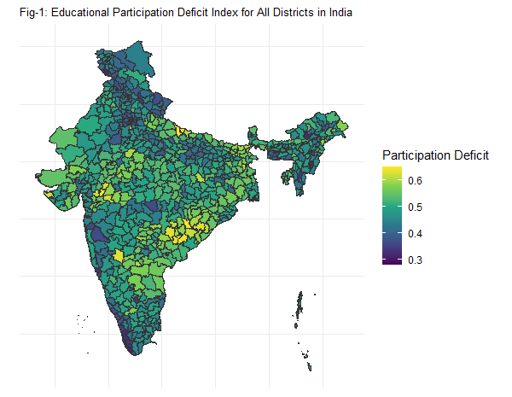 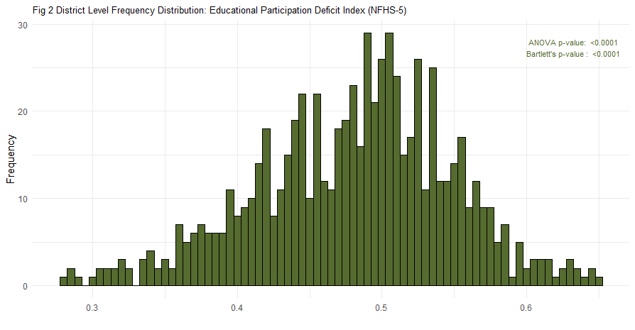

In Figure 1 , we observe that the distribution of educational participation exhibits spatial clustering, where neighboring districts manifest similar participation patterns. This phenomenon is starkly illustrated by the striking disparities between major urban centers and more marginalized districts. Mumbai and Chennai, for instance, exhibit participation deficit indices of 0.2783 and 0.2845, respectively, situating them far ahead of Bahraich in Uttar Pradesh, which registers the most severe educational participation deficit in the country at 0.6509. Nabarangapur in Odisha follows closely with a deficit of 0.6457693. Such disparities compel us to examine the spatial clusters and to interrogate whether the primary mechanisms of educational participation deficits also exhibit similar clustering. Prior to our spatial analysis, we will present additional summary statistics, which underscore that heterogeneity and variability are not confined to inter-district comparisons but permeate within districts and across communities.

**Data :** In the study we have worked with IPUMS-[DHS 2019-21 [India]](https://dhsprogram.com/pubs/pdf/FR375/FR375.pdf) data which is the National Family Health Survey-5 [NFHS-5] data and it is the largest sample survey conducted in India to date. The National Family Health Survey 2019-21 (NFHS-5), the fifth in its series, provides comprehensive data on population, education, and nutrition for India, its states, union territories (UTs), and 707 districts. Conducted under the stewardship of the Ministry of Health and Family Welfare (MoHFW) and coordinated by the International Institute for Population Sciences (IIPS), NFHS-5 was funded by MoHFW and received technical assistance from ICF, USA. The survey, executed in two phases, amassed information from 636,699 households, 724,115 women, and 101,839 men. NFHS-5 builds on the foundations of previous surveys, starting from NFHS-1 in 1992-93, maintaining continuity in content and methodology while progressively expanding its scope. NFHS-4 (2015-16), with its enhanced sample size, provided district-level data and ensured comparability with earlier rounds. Similar to NFHS-4, NFHS-5 delivers district-level estimates for numerous crucial indicators, including the wealth index, which is extensively utilized in this study. It also introduces the new topic of preschool education, while continuing to cover incomplete education, access to schooling, reasons for drop-out, and occupation history. These elements enable a thorough analysis of educational participation and its socio-economic implications at both district and national levels, as well as the spatial spillover of educational barriers. The NFHS-5 sample design aimed to produce reliable data at the district, state/UT, and national levels. A uniform, stratified two-stage sample design was adopted, with districts stratified into urban and rural areas. Rural strata were further sub-stratified based on village population and the percentage of the population belonging to scheduled castes and scheduled tribes (SC/ST). Villages and Census Enumeration Blocks (CEBs) were chosen as Primary Sampling Units (PSUs), sorted by women's literacy rates in rural areas and by SC/ST population percentages in urban areas before selection. Rural villages were selected with probability proportional to size (PPS), and each rural stratum was divided into six approximately equal substrata. Urban CEBs were sorted similarly, and PSUs were selected using PPS systematic sampling. Each PSU or segment of a PSU had an estimated 100-150 households, with 22 households per cluster selected through systematic sampling. A total of 30,456 PSUs were selected across the country, with fieldwork completed in 30,198 PSUs. Four survey questionnaires—Household, Woman, Man, and Biomarker—were translated into 18 local languages and administered using Computer-Assisted Personal Interviewing (CAPI). Data was collected on household demographics, socio-economic characteristics, health insurance coverage, digital banking, Internet usage, land ownership, and mosquito net usage, among other topics. The survey also included extensive training and quality control measures. Training of Trainers (ToT) workshops were conducted for field coordinators, who then trained fieldworkers at the state/UT level. Fieldwork was monitored by multiple levels of supervisors, including district coordinators, IIPS project officers, and senior staff from Field Agencies. Data quality was ensured through daily data transfers to IIPS, extensive data quality checks, and real-time feedback to field teams. NFHS-5 achieved high response rates, with 98% of selected households successfully interviewed, 97% response rate for women, and 92% for men. The data collected provide valuable insights into India's health and family welfare landscape, assisting policymakers and program managers in setting benchmarks and assessing progress. This extensive and detailed survey is the largest sample survey conducted in India to date, offering critical data to inform public interventions and policy decisions.

**3.1 Summary Statistics :**

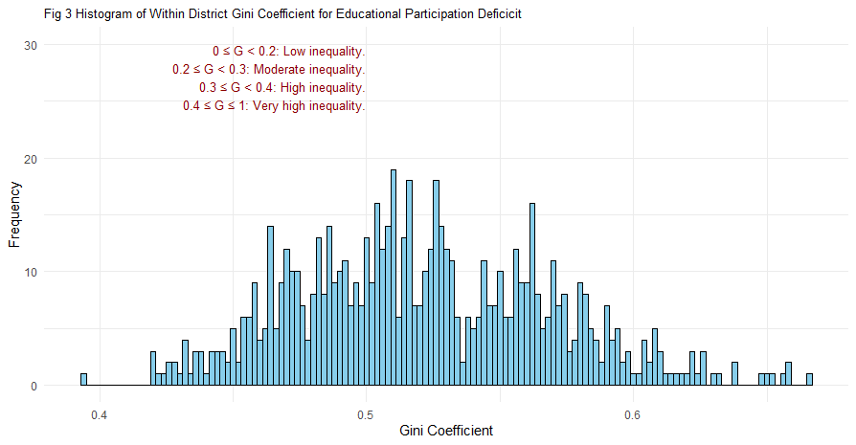 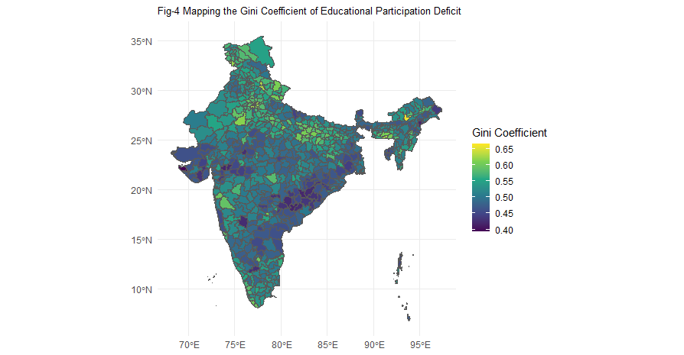

Contemporary literature on education in Indian districts underscores the profound interplay of socio-economic factors, including caste dynamics, on educational outcomes. Studies such as those by Desai et al. (2010) and Dreze and Sen (2013) have documented the entrenched inequalities in educational attainment linked to caste and socio-economic status. These disparities are not merely reflections of economic inequities but are also perpetuated by social and cultural barriers. For instance, children from Scheduled Castes (SC) and Scheduled Tribes (ST) navigate a labyrinth of challenges in accessing quality education, ranging from discrimination within schools to a lack of educational resources in their communities . Barriers to education in these contexts are multifaceted. The impact of these barriers is particularly pronounced in rural areas where economic constraints, gender discrimination, inadequate infrastructure, and insufficient teacher training are critical factors that exacerbate educational inequalities. Research by Banerjee and Duflo (2011) highlights how economic hardships limit educational opportunities for children in impoverished households, leading to a cycle of disadvantage. In Table-1, we have provided a summary across different demographic age groups, rural/urban positions, gender, and caste, assessing the statistical significance where we found most tests to show significance.

The histogram (Figure -3) of the Gini coefficient for educational attainment across districts showcases a broad spectrum of inequality levels and underscores that almost all districts display significant internal heterogeneity, irrespective of overall participation rates. Figures 3 and 4 highlight the overall heterogeneity in educational attainment within districts. The Gini coefficient, a measure of statistical dispersion, represents income or wealth inequality within a nation or social group. It ranges from 0 to 1, where 0 indicates perfect equality (everyone has the same income or wealth) and 1 indicates perfect inequality (one person has all the income or wealth, and everyone else has none). This indicator can also be used to measure inequality in other distributions, such as educational attainment or health outcomes . A Gini coefficient of 0.4 or above is generally considered as very high Inequality.

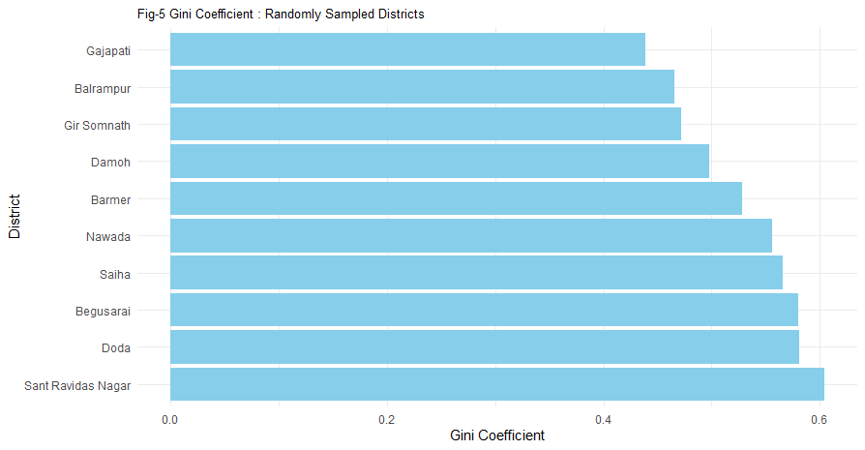

Fig-5 further elucidates this point by showcasing a random sample of districts with the

random levels of within-district educational inequality, emphasizing that most districts

might have need for targeted interventions.

Jalan and Ravallion (2002) noted that geographic disparities in education are closely linked to broader patterns of regional development and poverty. But, in our data we see notable concentration of districts experiencing moderate to high inequality (Gini coefficient between 0.3 and 0.5) irrespective of overall participation rates (as observed in Figure 1). So, it will be reasonable to explore whether regions with higher participation deficits always correspond to areas with longstanding socio-economic disadvantages and even if it does, there will certainly be other principal actors. For instance, Mumbai and Chennai, which have high educational participation and low deficit indices of 0.2783 and 0.2845, respectively, exhibit Gini coefficients of 0.638 and 0.647, signalling substantial inequality within these highly participative districts. Conversely, Nabarangapur in Odisha and Bahraich in Uttar Pradesh, which suffer from the worst participation deficits at 0.6457693 and 0.6509, respectively, display Gini coefficients of 0.4207 and 0.4467. This is likely because there is limited room for variability at the lower end of the threshold. However, this suggests that even developed urban centres with high participation can exhibit significant within-district inequality . However, spatial clustering of educational participation deficits, as indicated by the map in Figure 1, also finds some reflection in Figure 3. While high participation clusters may not coincide with high inequality clusters, the presence of these clusters points to regional patterns of inequality likely stemming either from historical, economic, and policy-driven factors, as noted by Jalan and Ravallion (2002), or from the fact that demographic communities facing the highest discrimination often come from regions where there may be national-level oversight or local discrimination affecting overall attainment. Research by Kingdon (2007) and Tilak (2007) supports the notion that educational inequalities in India are deeply rooted in socio-economic and cultural factors. Kingdon's study highlights the role of gender and caste in shaping educational outcomes, while Tilak emphasizes the need for substantial public investment in education to bridge these gaps. These insights underscore the multifaceted nature of educational disparities and the necessity for targeted interventions that address both economic and social dimensions of inequality. Along with gender and caste, in this study we also explore the disparity between different religious groups.

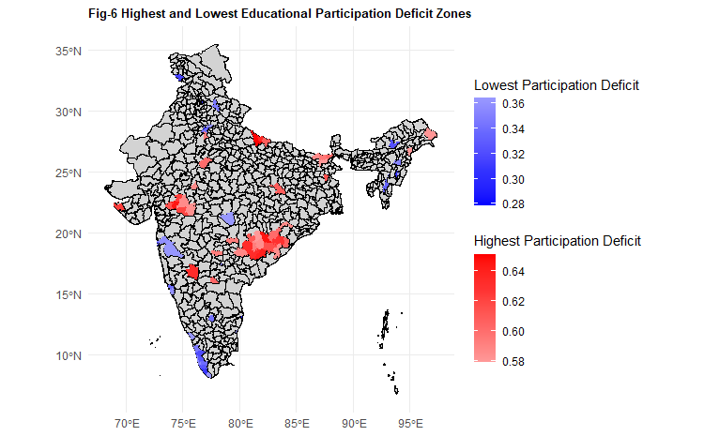In conclusion, within-district educational participation deficits underscore the significant and varied challenges to achieving educational attainment in India, as a part of Minimum Development Goals. Addressing these disparities requires an unbiased approach that considers the socio-economic and cultural contexts of different regions and tests existing hypotheses regarding both the demand and supply sides of education for marginalized communities. This aligns with the broader literature advocating for comprehensive strategies to bridge educational gaps and promote inclusive growth. Figures 3 to 6 provide a visual representation of the complex landscape of educational inequality in India, emphasizing both within and between district disparities. In Table-1, we will see the statistical significance and exact figures regarding these disparities as part of our initial exploratory analysis in elaborate manner.

**Table 1: Average Individual Educational Participation Deficit Scores Across Demographic Group**

One notable divergence from the existing findings in the NAS (National Achievement Survey 2023) report, which demonstrated that girls outperformed boys in learning outcomes and enrollment levels, became apparent when we considered enrollment data from the much larger NSSO sample. When we distinguish between urban and rural environments, the numbers we uncovered showed that, in most cases, the participation rate of girls was lower than that of boys contrary to the NAS report which perhaps overrepresented the urban households. In Table 1, we see an inverse nature of the participation deficit between boys and girls in the age group 12-18 years old: In urban areas, likely to host private schools, girls exhibit higher enrollment rates than boys. In contrast, in rural regions, predominantly served by public schools, boys' enrollment surpasses that of girls. This discrepancy between enrollment, when viewed through the lens of age-specific grouping and graded coding of educational participation, illuminates the disuniformity of student attrition between successive grades.

In Fig -7 we can discern the overall frequency counts of statistically significant and non-significant differences when we look at each district separately and we observe the skewedness of this distribution . In our exploratory analysis above, we have charted the landscape of educational participation across districts by presenting district-wise overall participation rates. This offers a granular view of educational engagement. Additionally, we have calculated and depicted the Gini Coefficient for each district, a metric that elucidates the inequality in educational participation at the district level. By plotting the distribution of these Gini Coefficients, we have highlighted regions with significant disparities, thereby enhancing our understanding of the intensity of local barriers to participation (Fig 2). To provide context to our findings, we have incorporated specific examples from over 700 districts, casting light on familiar places so that readers can relate to known districts and understand the state of educational participation in their regions (Fig 1, Fig 4). The focus of our analysis has been the discrepancies between demographic groups—male versus female, SC/ST/OBC versus General/upper caste, and Muslims versus other religious groups. Our findings reveal stark contrasts in educational participation. The urban-rural divide is also critical to examine in this context of inequality (Table 1). While district-level statistics offer granular insights, understanding the overall inclination at the national level necessitates examining the ratio of high and low-performing districts concerning the respective demographic groups. To this end, we have conducted district-wise t-tests and presented the results using dot plots (Fig-7).

In our subsequent analyses, we will sustain the district-level focus of our investigation; however, the novel question we will address pertains to the influences exerted by neighboring districts, an inquiry that mandates the utilization of spatial statistical methods. In clusters where neighboring districts consistently underperform, the necessity for targeted interventions becomes glaringly obvious. Exploratory work or general regression methods are insufficient to capture these intricate spatial effects. We will first illustrate that such spatial effects exist and are significant. Therefore, before delving into analyzing the returns on education and investigating potential evidence of active discrimination once education is controlled for, to achieve true unbiasedness, it will be crucial to obtain estimates that also account for the influence of neighboring districts across different demographic groups. In the following sections, we will employ a range of spatial statistical methods to present the discussion with theoretical sections as needed, ensuring that theory, examples, and results are presented side by side to make the information easily accessible and comprehensible for the reader.

**3.2 Spatial Exploratory Data Analysis :**

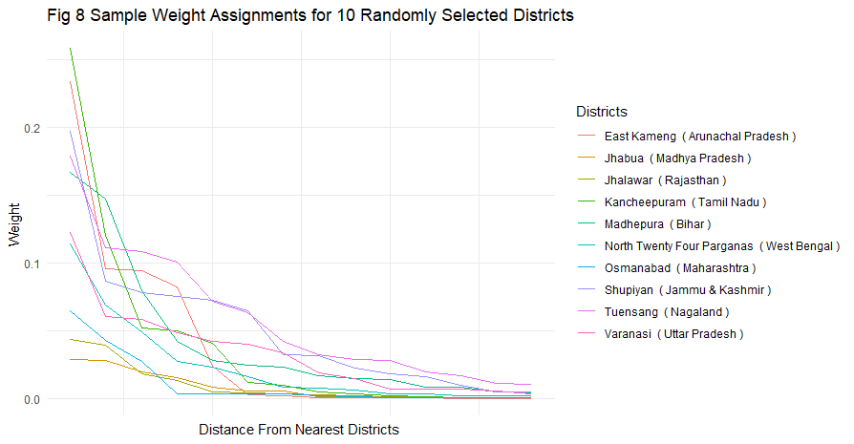Moran's I statistic is a fundamental tool in spatial analysis, used to measure spatial

autocorrelation —that is, how much a variable is correlated with itself across a given space. In our framework it is used to identify whether we have evidence for spatial autocorrelation between participation rates at neighboring districts i.e. whether spatially proximate social units have spillover effects on mutual supply and demand of education.

**:**

*: , :* Mean across all locations

Selecting an appropriate weighting matrix has various potential options where nearest neighbors are always assigned higher weights. Generally, different types of weighting matrices can be considered. In our study, the initial assumption posits that spatial effects are not confined by state (admin 1 level) boundaries, thereby a straightforward 707by707 weighting matrix can be sufficient, at least initially. For our study, with a threshold of 0.2. This chosen threshold brings the weight to zero approximately after the nearest 7th district ( depending on how large and distant the districts in that cluster are) ensuring that distant influences are minimized exponentially . Figure 8 illustrates this rate of decay i.e. what a threshold of 0.2 means, and how the influence diminishes with increasing distance. For example, weights assigned to Jhalwar (Rajasthan), where neighboring districts are larger, diminish sharply and decay to zero approximately after the 5th district. In contrast, for Tuensang (Nagaland), the weight does not decay to zero even after the 15th district because the northeastern part of India has smaller districts. To note, this weight structure is a general function of distance. When applied to our dataset, it reveals the spatial lags and global autocorrelation between participation rates (Figure 9). The Moran’s I value is positive and significantly high (Moran’s I = 0.6136, p-value < 2.2e-16). This is our statistical evidence that educational participation is not randomly distributed but follows a pattern influenced by spatial proximity.

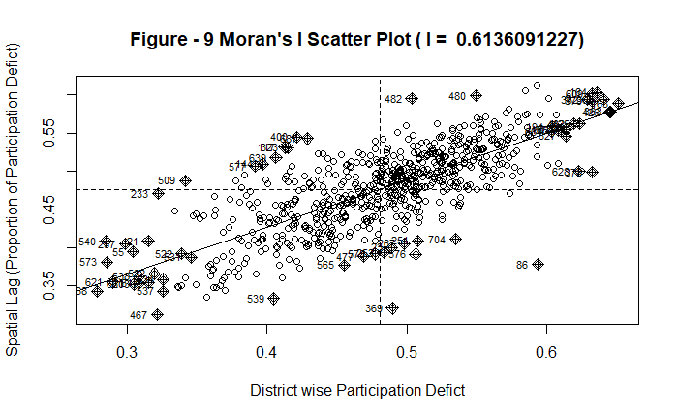

In Figure 9, on the X-axis, we plot the rates of participation deficit for each district, while the Y-axis represents the spatial lag. This visualization shows the spatial clustering of educational participation rates at a global level.

The local spatial correlation is given by:

LISA stands for Local Indicators of Spatial Association.

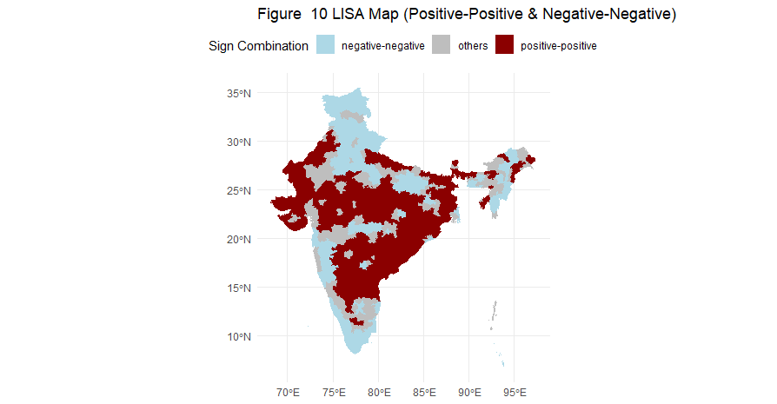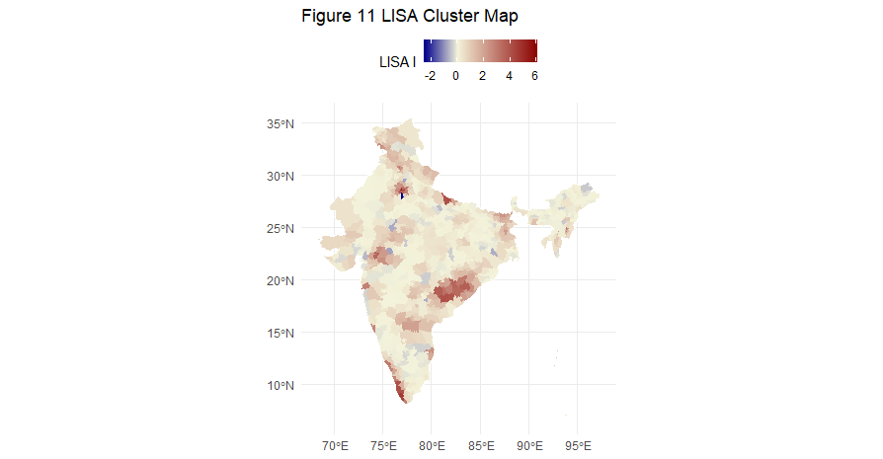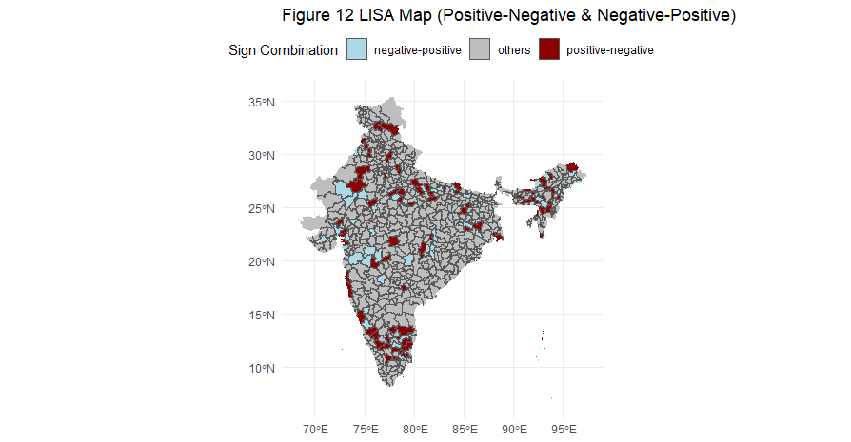The observations can be classified into 4 categories based on the LISA I values. A positive LISA I signifies that a district is surrounded by others with similar educational characteristics, creating clusters of homogeneity (Fig. 10). Conversely, a negative LISA I indicates points of discontinuity, where a district is encircled by districts exhibiting different states of education, thus identifying these as spatial outliers [Fig 12]. These outliers are further distinguished as HOT or COLD spots, contingent upon whether their educational participation rates are significantly higher or lower than the average.

**3.3 Empirical Analysis : District Level Regressions**

In this section, we decompose the total variabilities of educational participation at each district level :

This is our regression model fordistrict. We perform 707 district-level regressions for 707 districts of India:

Here,

Household level random effect for Household at district.

Number of years of education for individual from Household at district.

(We focused on an age group ranging from 5 to 25 years old)

,

Some districts did not meet the full-rank requirements, and when the number of observations from a particular demographic subset is very low, the estimates lack statistical power and meaningfulness. For instance, in Kupwara, Jammu & Kashmir, we did not have enough female SC/ST observations. In such cases, we excluded that demographic category as a cofactor in the district-specific regression and also excluded the respective interaction effect.

Our models had a median of 0.7412, with the 1st and 3rd quartiles at 0.6956 and 0.7932, respectively.

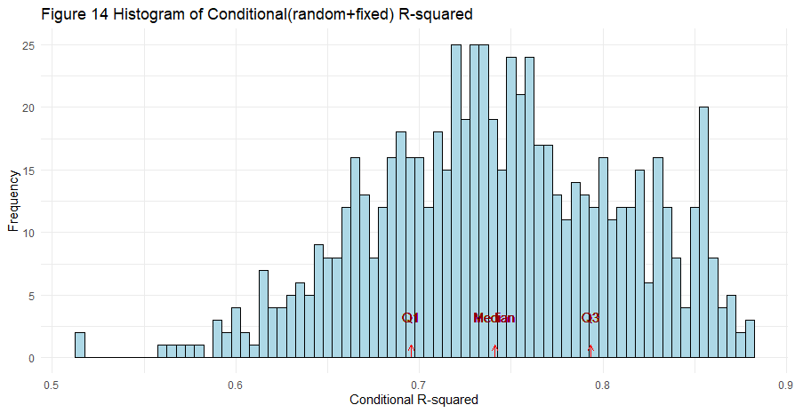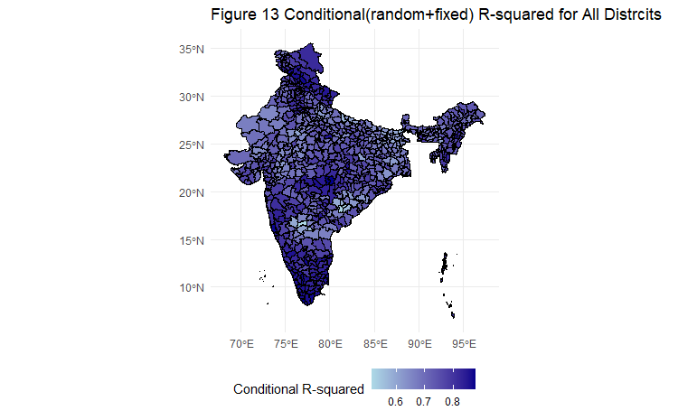

**Our model describes a significant proportion of total variability**

**The Estimates:** While this model captures a significant percentage of variability, our aim is not predictive analysis. Rather, we seek to interrogate the distribution of the coefficients for Female (i.e., when the individual is female; female = 1), Muslim (i.e., when the individual is muslim; muslim = 1), and SC/ST (i.e., when the individual is SC/ST; SC/ST = 1). We focus on discerning the districts where these estimates hold significance and identifying the hot points within these spatial distributions. In Fig-4-6 we show the main-effects (i.e. not the interaction effects):

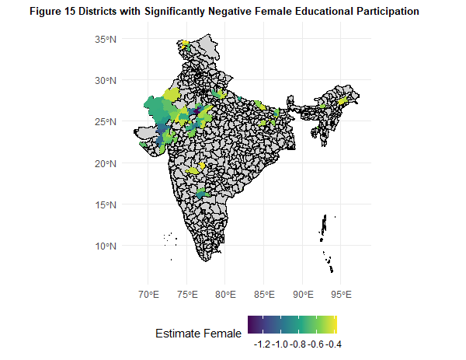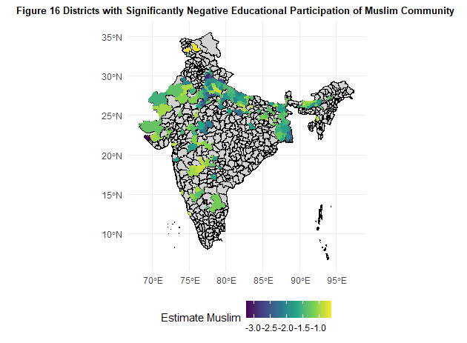

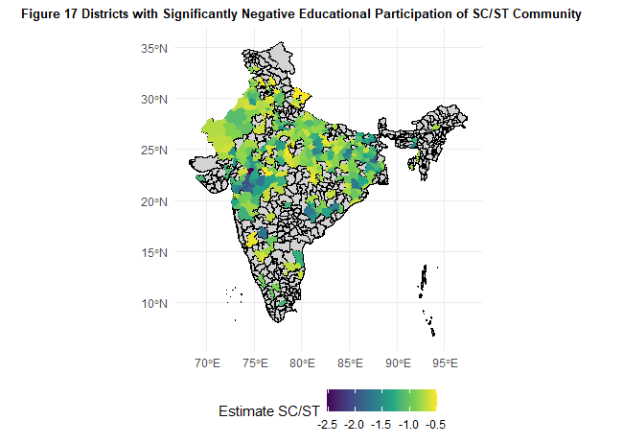 Among the districts with adequate observations, we identified:

a) Female participation in education for the age group of 5 to 25 was notably low in 9.47% of districts (67 out of 707 districts), with a p-value of less than 0.01.

b) For the same age group in Muslim communities, 53.31% of districts (185 out of 347 districts) showed similarly low participation rates. (in rest of the districts we did not have adequate Muslim responders)

c)For SC/ST groups, this low participation was observed in 42.56% of districts (275 out of 646 districts).

* **Do Muslim or Dalit (SC/ST) women encounter greater barriers to participation due to regressive attitudes within households in backward communities?**

We examine the interaction effects, which represent the non-linear component beyond the additive effects of the two factors Female and Muslim/SC/ST:

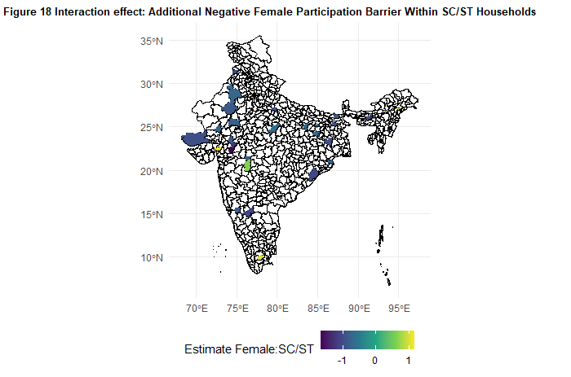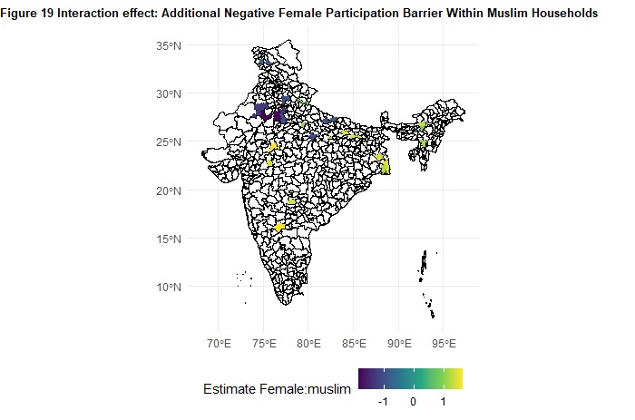

This indicates that the common belief that Muslim and SC/ST households are particularly regressive towards women is not justified, at least with respect to the barriers to educational participation in India, based on the data that we have collected in 2019-21.

**The Local Clusters/hot spots suing LISA:** Finally, we examined Local Indicators of Spatial Association (LISA) to identify the districts that exert strong influence

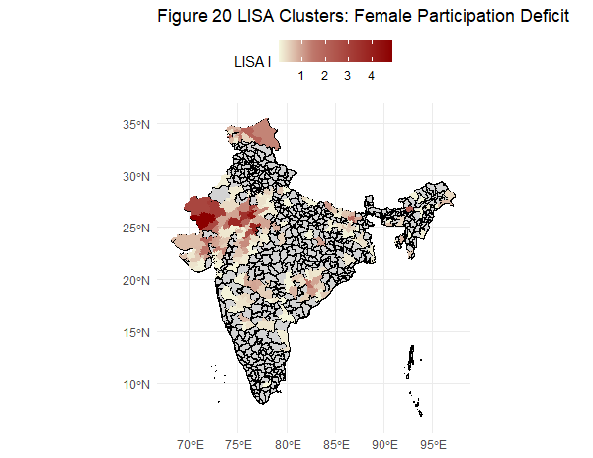 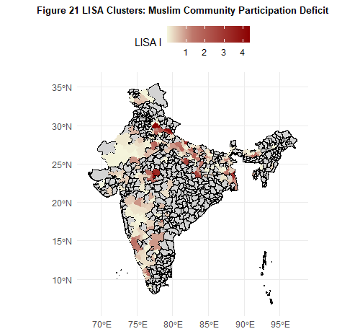 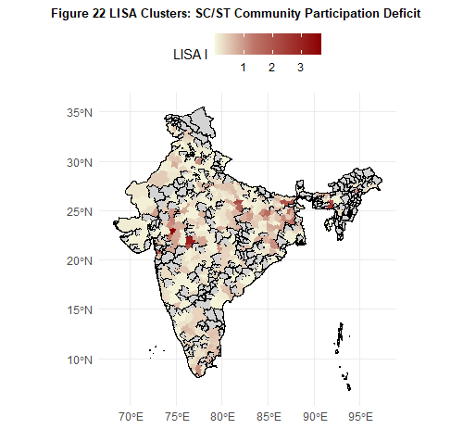

**3.4 Does educational participation provide equal benefits across different genders and communities?**

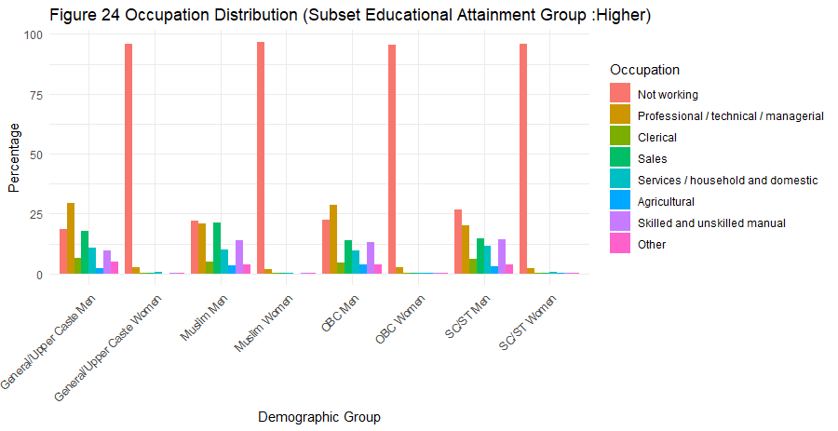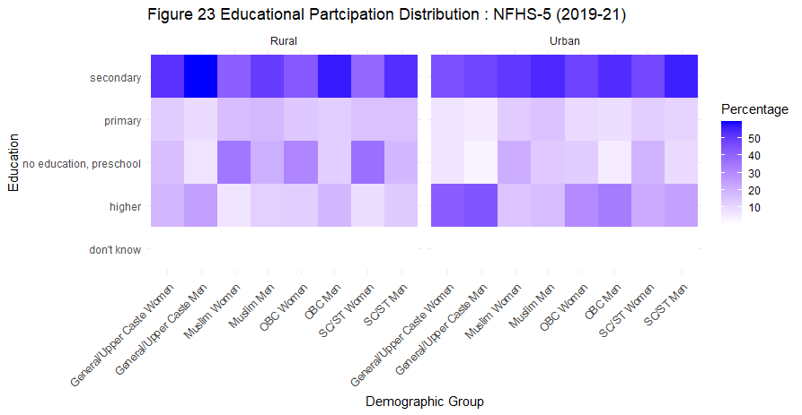

According to the World Bank, a one-year increase in the average years of schooling can elevate a country's GDP growth by 0.37%. Similarly, a 1% increase in the literacy rate can enhance GDP growth by 0.3%. "Pre-market endowment" encompasses the array of skills, education, and other attributes—such as overall health, physical condition, social and cultural capital, and personal characteristics like intelligence and motivation—that individuals possess before entering the labour market. These pre-market endowments critically shape job opportunities, earning potential, and career trajectories. In this section, we seek to interrogate the extent to which education alone can act as a sufficient or predominant catalyst for economic growth within this diverse nation. Furthermore, we examine the junctures and demographic contexts where additional, targeted interventions may be imperative to address the complexities of systemic inequities.

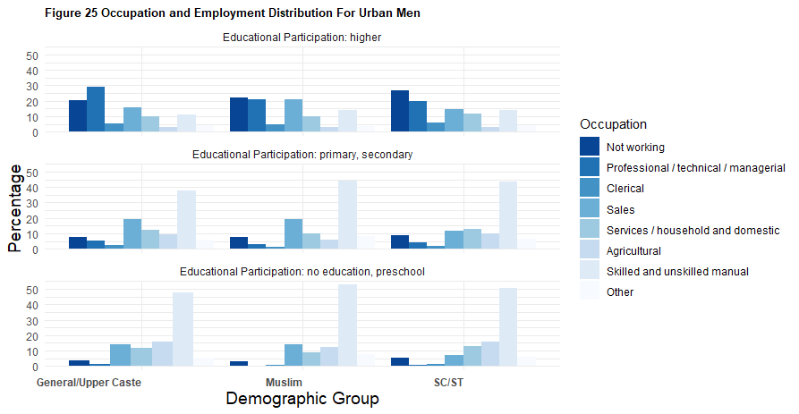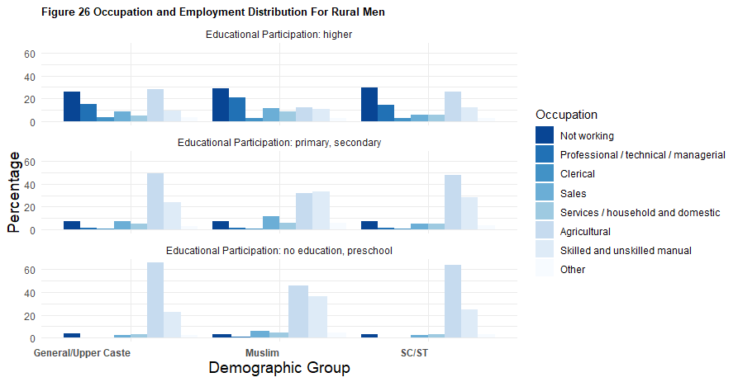

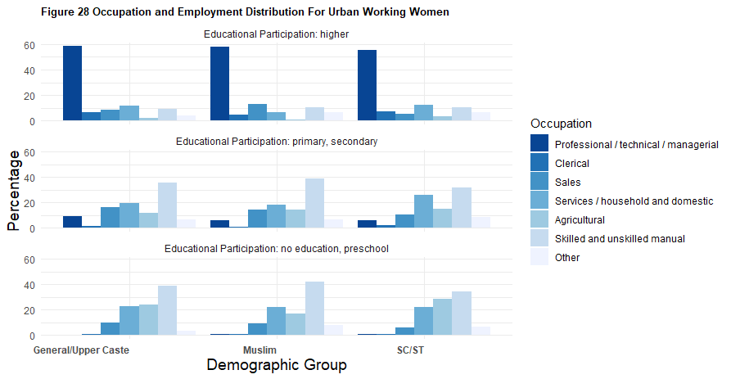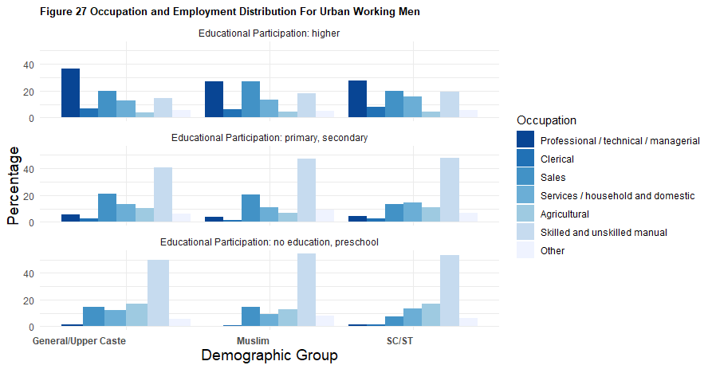

Fig -25 and Fig - 26 show a comparison between urban (Fig 25) and rural (Fig 26) men who are 18 years old or older. The comparison looks at different education levels and how education impacts job clustering. As men from different demographic groups progress from having no education to primary/secondary education and then to higher education, the graphs illustrate how they tend to group into different occupations and the differences in returns to pre-market educational attainment for the three demographic groups. In contrast, Figures 27 and 28 focus on urban working women and men. It is certainly troubling that many women are not part of the workforce despite higher education (as shown in Figure 23 & Figure 24), and it is important to note that a considerable number of men, particularly in rural India, with higher education are also out of the workforce. But in the current analysis we also aim to discern the persistent gender discrepancy in the labor market i.e., the extent to which educational attainment benefits men over women, even among those who are employed.

Our observations align with ordinary understanding and corroborate the district-level analysis previously conducted in Section 2:

* With education, the likelihood of securing professional, technical, or managerial positions increases for all groups.
* Social and cultural capital plays a significant role, as men from the general category tend to secure more sophisticated and higher-paying jobs compared to Muslim and SC/ST men. This suggests the presence of discrimination or barriers for Muslims and SC/STs, as their occupational clustering differs despite having similar educational attainment, skills, and training. In Table 2 (at the end of this initial discussion), we have provided the exact values.
* Learning outcomes may vary between rural and urban areas. This could be due to differences in learning outcomes or a lack of suitable job opportunities and awareness of job information and trends.
* Among urban men and women with higher education, men predominantly work in professional, managerial, and technical jobs, while women are more likely to work in sales as well as professional roles.
* For all groups, the percentage of unskilled manual laborers decreases as they progress from having no education or only secondary education to obtaining higher education.
* Additionally, one specific and intriguing observation here might contradict the conventional expectation and perhaps may also be a barrier to promoting educational participation. In Figures 3 and 4, we observe that while higher education should theoretically facilitate a shift from unskilled manual or agricultural labor to advanced technical roles for both rural and urban men, it concurrently elevates the risk of unemployment. We see, rural men who transitioned from agricultural work to higher education, most likely face joblessness if they fail to secure advanced positions. Similarly, urban men previously employed in unskilled manual jobs also confront increased unemployment after obtaining higher education. This counterintuitive outcome is particularly pronounced among Muslim and SC/ST groups, who, despite attaining higher education, face a disproportionately elevated risk of unemployment.

In summary, these socio-cultural determinants—caste, religion, geographic locality (rural or urban), and gender—persist in their influence, demonstrating that systemic structures and power dynamics are deeply embedded within the labor market. While it is evident that discrimination is more acute in rural areas, urban areas also reveal statistically significant disparities. Yet, education emerges as a potent site of potential disruption and upward mobility, particularly through the acquisition of higher or tertiary education, which can serve as a transformative force, albeit within the constraints of existing hierarchies. In Table 2, we present the numbers behind the above plots :

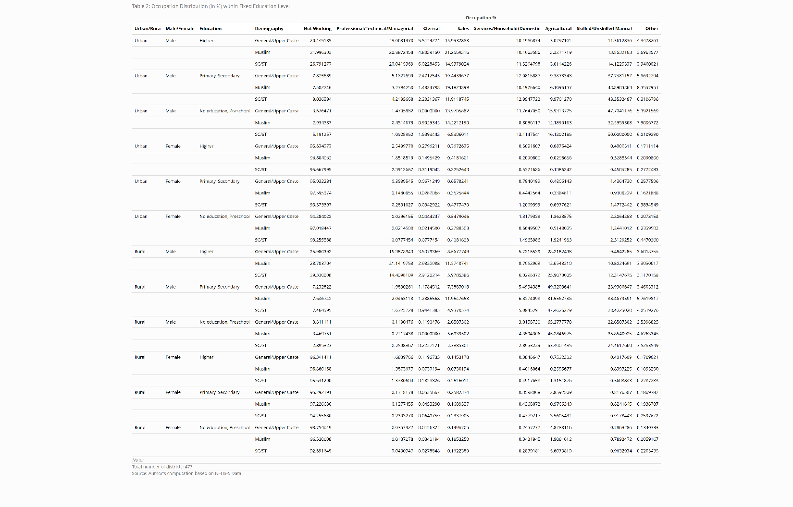

In **Table 2**, for now, we provide these figures and will revisit the statistical significance and implications of these numbers in the next section with more sophisticated statistical tools. Some of these differences may not immediately appear significant, but deeper analysis reveals important insights. For instance, over 95% of highly educated rural women are unemployed, leading to a non-significant chi-square value. However, when the 'Not working' category is excluded, significant differences in employment distribution among general, Muslim, and SC/ST groups emerge, with a p-value of 0.007. This underscores the complexities and challenges in making precise judgments for each group. Finally, it is crucial to highlight that the single most striking and statistically significant difference emerges in relation to gender. Women who have attained higher education remain largely unemployed, revealing a profound disjunction. While Figure 1 shows that men and women pursue further education almost equally across demographic groups, their employment statuses diverge markedly. For Muslim and SC/ST communities, barriers to education were more significant than barriers to occupation within same education level. In this context, it is important to recall that geographical disparity is one of the prominent sources of variability, a factor that could not be accounted for in the above calculation. To understand this further and to explore other socio-financial parameters and the broader implications of educational attainment, we have performed additional analyses on various socio-financial indicators.

**Generalized regressions (global)**: The following section presents the Empirical Models, aimed at estimating the relationship between an outcome variable of interest (Y) and predictors (X), with a focus on the effect of education in conjunction with demographic factors. The source of dependence may stem from demographic factors alone or may not show significance when controlled for education. This combination of variations leads to the development of two types of logistic regression models:

*vs*

where:

*logit(p)* is the log-odds of the probability *p = P(*

*β0* is the intercept of the model.

*β1​,β2​,…,βk​* are the coefficients representing the effect size of each predictor (including education, wealth, and demographic factors).

*ϵ* represents the error term, which in the context of logistic regression, follows a binomial distribution.

The following tables summarize the results:

We find that participation in education positively influences the likelihood of financial inclusion, specifically in terms of having a bank account. However, the impact is considerably higher in rural areas, where the odds increase by 25.5% compared to an increase of only 8.4% in urban areas. Despite the known lower learning outcomes in rural schools, education significantly enhances financial inclusion in these areas. However, when controlled for education (i.e., within the same education groups), we do not observe any significant change in participation for Muslim or SC/ST individuals, while we see a notable change for general/upper caste women (Please note that the percentages need to be converted to exp(x) of the coefficients).

In Table 3B, a pivotal observation emerges: the coefficients for SC/ST and general/upper caste groups exhibit opposing signs when considering government versus private insurance provided by employers. This pattern reveals that SC/ST individuals are disproportionately excluded from employer-provided insurance, whereas general/upper caste individuals actively avoid government insurance. Crucially, this disparity remains pronounced even when controlling educational attainment, underscoring the persistent structural inequities at play.

In Tables 3C and 3D, a stark revelation emerges regarding occupational attainment across different communities. Both in rural employment and urban white-collar jobs, even after controlling for education, SC/ST and Muslim communities lag behind their similarly educated general/upper caste counterparts. SC/ST men are approximately 39% less likely to secure a white-collar job (exp(-0.5) ≈ 0.607), and Muslim men are about 14% less likely (exp(-0.146) ≈ 0.864). Similarly, SC/ST women and Muslim women are significantly disadvantaged compared to general/upper caste women, with probabilities 33% (exp(-0.40) ≈ 0.670) and 56% (exp(-0.815) ≈ 0.443) lower, respectively. In terms of overall employment, SC/ST and Muslim men are 18% (exp(-0.194) ≈ 0.824) and 29% (exp(-0.34) ≈ 0.711) less likely to be employed than their equally educated general caste counterparts. Furthermore, it appears that higher education may paradoxically disadvantage SC/ST men in rural areas, as the sign of the coefficient shifts from positive to negative when controlled for education. Muslim women in rural areas face severe employment barriers, being 44% less likely to have any kind of job compared to equally educated general/upper caste women (exp(-0.583) ≈ 0.558). Lastly, the gender disparity is the most pronounced: women are 96% less likely to hold white-collar jobs (exp(-3.294) ≈ 0.037), and in terms of rural employment, they are 99% less likely (exp(-4.939) ≈ 0.007). These findings underscore the persistent and pervasive structural inequities faced by these communities.

Lastly, in Table 3D, we investigated the impact of education on digital banking usage among various caste and religious groups, as well as among women. Contrary to the patterns observed in Table 3A, we find that mobile banking usage increases for both Muslim and SC/ST men, shifting from 20% lower participation (exp(-0.218) ≈ 0.804) to 1.8% higher participation (exp(0.018) ≈ 1.018) for Muslim men, and from 35.5% lower participation (exp(-0.438) ≈ 0.645) to 24.1% lower participation (exp(-0.276) ≈ 0.759) for SC/ST men i.e an 11% increase. Among rural women, with educational control, the coefficient for Muslim women rises from 22.1% lower participation (exp(-0.246) ≈ 0.782) to 7.7% lower participation (exp(-0.08) ≈ 0.923) i.e. a 15% increase , and for SC/ST women, it increases from 23.1% lower participation (exp(-0.263) ≈ 0.769) to 10.4% lower participation (exp(-0.11) ≈ 0.895) i.e. a 135 increase. Unlike in Table A, where physical bank account proportions were discussed, women experience a significant disparity in digital banking, reflected by 93.5% lower participation (exp(-2.731) ≈ 0.065) compared to men, instead of the 25.5% higher participation (exp(0.227) ≈ 1.255) noted for physical banking. This shift indicates that the discrimination faced by SC/ST and Muslim communities is rooted in institutional barriers within physical banking. Outside the scope of physical banking, their educational attainment markedly improves their engagement with financial services, highlighting a profound divergence in access and inclusion.

In Table 3F, we observe that the socio-economic indicator "Can read SMS" among rural Muslim women shows a substantial improvement when schooling years are controlled for. Specifically, the coefficient shifts from 17% lower participation (exp(-0.19) ≈ 0.827) to 0.1% lower participation (exp(-0.001) ≈ 0.999), indicating a 16.9% increase in participation. This indicates that schooling years significantly improve the ability of rural Muslim women to read text messages, which is crucial in the digital age. This improvement suggests that these women do not lack awareness but are subject to active discrimination. Similarly, in the same table, we see that the socio-economic indicator "Smokes at Home" for non-Muslim men also shows a marked improvement for SC/ST men when schooling years are accounted for. The coefficient for SC/ST changes from 7.7% higher participation (exp(0.074) ≈ 1.077) to 0.4% higher participation (exp(0.004) ≈ 1.004), indicating a 7.3% decrease in participation. This highlights that controlling for schooling years significantly reduces smoking at home among SC/ST men, indicating that education plays a vital role in mitigating this behavior. These findings underscore that the disparities observed are not due to a lack of awareness but rather reflect underlying discrimination. Educational attainment helps bridge these gaps, reinforcing the need for targeted educational interventions

In summary, our analysis is evidence, and it lays bare the deeply entrenched and multifaceted discrimination faced by Indian SC/ST and Muslim communities , which persists despite their educational attainment. Even with comparable pre-market endowments, such as years of schooling, these groups face formidable barriers in occupational attainment and institutionalized discrimination in physical banking. The stark disparity in returns to schooling years—where SC/ST and Muslim individuals derive significantly fewer benefits than their general/upper caste counterparts—highlights the pervasive structural inequities that education alone cannot hope to dismantle. Furthermore, their proficiency in digital banking and literacy in reading SMS messages indicates that the issue is not one of awareness but rather of systemic and deliberate discrimination. These findings make it abundantly clear that targeted interventions are necessary to address these deeply rooted and institutionalized barriers. This might be a significant barrier to promoting education in these communities.

**3.5 Wealth and Social Class Transitions: A Markov Chain Analysis**

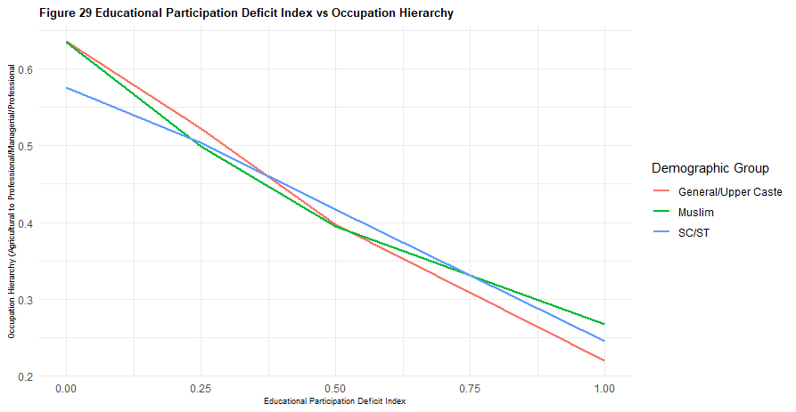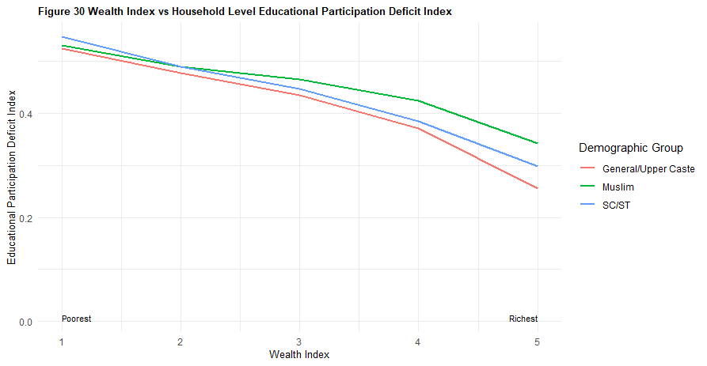

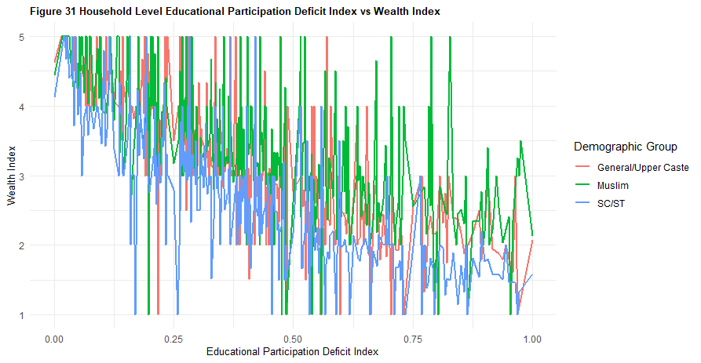 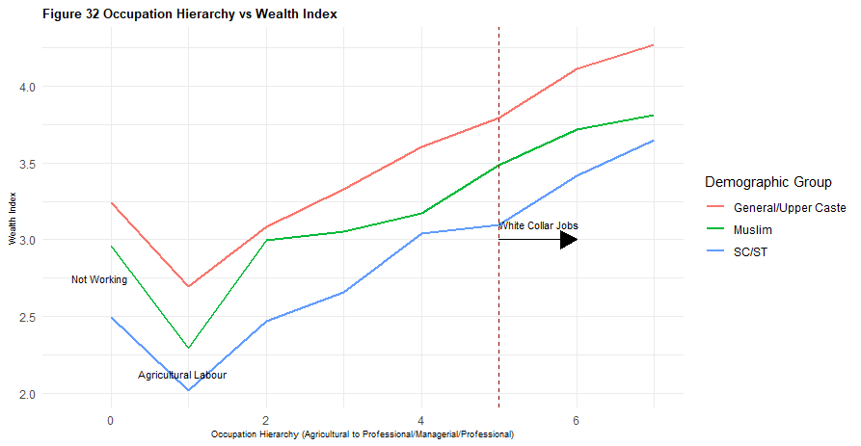

In this section, we aim to consolidate the figures and numbers discussed so far and summarize the discussion to answer the ultimate question of transitioning from a poorer socio-economic stratum to a richer class (or vice versa). This transition is the culmination of the inequities we have observed, sequenced one after another, and situated at the intersection of these inequalities: the multifaceted barriers to educational participation shaped by wealth, demography, and geography; the differentiated entry barriers into the labor market when comparing demographic groups with equivalent educational backgrounds; and the unequal patterns of wealth accumulation from identical occupations across these groups.

**Markov Chain Analysis** : As discussed in Section-2 Markov chain Analysis is a statistical method used to model and analyze the mobility between different states (such as wealth levels and social classes) . It aids in understanding the long-term probability and the impact of factors like education on these transitions. By applying the mathematics of axiomatic probability, we can discern who is more likely to remain in the poorest state and who shows the most promise (or risk) of moving to adjacent states, whether upwards or downwards. We begin with a straightforward question: For an 18 to 25-year-old individual, what’s the probability of starting in Wealth Category and moving to Wealth Category ? If we had panel data tracking the same individuals over an extended period, this would be a simple matter of calculating the proportions within the aggregate sets of individuals with varying accomplishments. However, such extensive data is rarely available, particularly in a country like India, with its 1.3 billion people and immense socio-economic and geographic diversity. So, we break down the question into manageable parts: a) What is the probability of an individual from Wealth Group achieving Education Level b) What’s the probability of an individual with Education Level obtaining Occupation ? c) What’s the probability of an individual in Occupation accumulating Final Wealth ?

For example,

For general/upper-caste group

a) P ( |W = ‘middle’) = % of 18-25 years old (excluding older age groups to reflect on the current state of education barrier) with education and Wealth index = ‘middle’.

From our data, the probabilities stand at: P ( = 6 years of education or less | W = ‘middle’) = 0.0929476 …(1)

P ( = secondary or incomplete secondary |W = ‘middle’) = 0.4229990 …(2)

P ( = completed/pursuing higher |W = ‘middle’) = 0.4425967 …(3)

b) P ( |) for= 1, 2, 3 can be calculated in the same manner from the % of 18+ years old ( we change the subset to all employable age groups)

The combined probability P ( |W = ‘middle’), for general/upper-caste group will thus be :

(*)

From our data, the probabilities stand at: P ( = Not working | W = ‘middle’) = 0.1435975 …(5)

P ( = Agricultural labour |W = ‘middle’) = 0.2778188 …(6)

P ( = Domestic/skilled/unskilled manual labour |W = ‘middle’) = 0.2984799 …(7)

P ( = Professional/clerical/sales |W = ‘middle’) = 0.2386471 …(8)

c) P ( Final wealth |) for= 1, 2, 3, 4, 5 can be calculated from the % of 18+ years old with occupation and Household Wealth Index

(**)

= (***)

by inserting (*) in (**)

= P ( |W = ‘middle’)

As a general expression : = P ( |initial wealth = )

= (****)

We will have a set of 5x5 = 25 such probability expressions which can be set as a 5X5 Markov Transition Matrix.

* **From our data , we have three Markov Chain Transition Matrices for General/Upper caste population , Muslim population and SC/ST population :**

Here, the cell = for respective demography as expressed in (****)

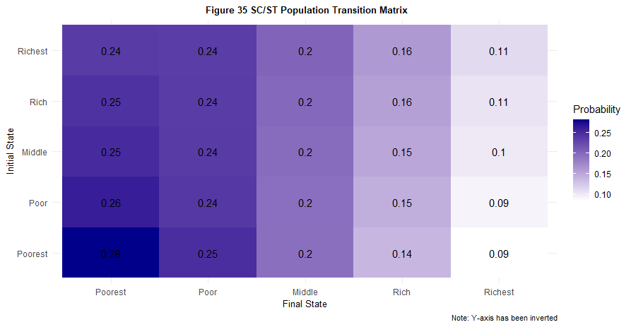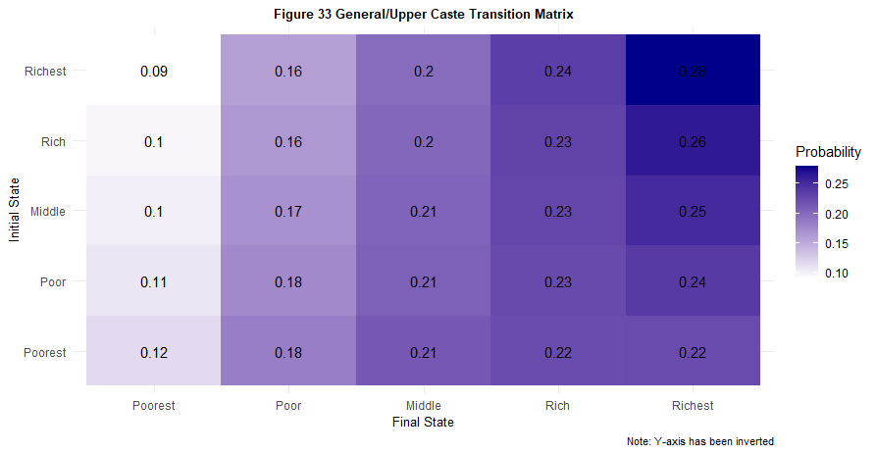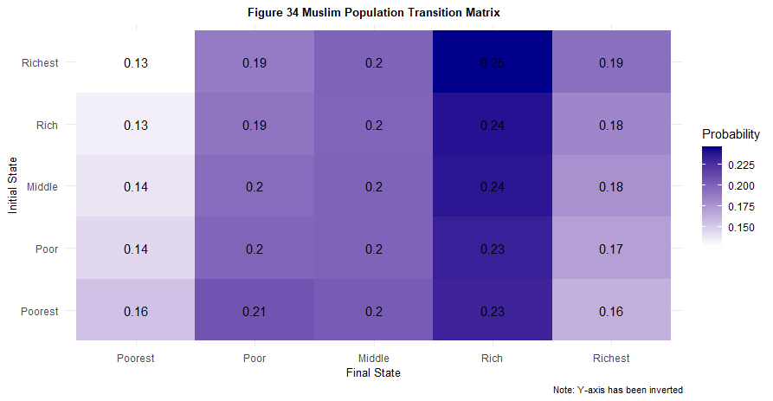

The Y axis has been inverted to enhance discernibility and allow for a more seamless reading of the data.

Each state transition matrix illustrates the transition probabilities of moving from one socioeconomic class to another.

In the **General/Upper Caste state transition matrix**, there is notable fluidity with significant probabilities of transitioning from lower socioeconomic classes to higher ones. For instance, individuals starting in the "Middle" state have a 23% probability of transitioning to the "Rich" state. The highest steady-state probability observed is for individuals in the "Richest" state remaining in the "Richest" state at 28%.

The **Muslim population state transition matrix** shows more restricted mobility. Although there is still some upward movement, the transition probabilities are lower compared to the General/Upper Caste group. Notably, individuals in the "Poor" state have a 24% chance of transitioning to the "Middle" state. The highest transition probability observed is for individuals in the "Middle" state remaining in the "Middle" state at 22%.

The **SC/ST population state transition matrix** highlights the challenges faced by this group. The transition probability of moving from the "Poorest" state to the "Poor" state is the highest among the three groups, reflecting significant barriers to upward mobility. The highest absorbing state probability observed is for individuals in the "Poorest" state remaining in the "Poorest" state at 28%; moreover, there is a troubling 24% probability of individuals in the "Richest" state sliding down to the "Poorest" state.

Thus, we observe distinct trajectories: clear upward mobility, constrained mobility, and disconcerting downward mobility and this dynamic is shaped by educational participation barrier, varying labor market entry opportunities, and pervasive pay gaps within the present structure. This sums up our exploratory and empirical analysis, highlighting not only disparities but also the troubling pattern observed in section 3.3, where higher educated individuals across all caste and gender categories exhibit a higher probability of remaining unemployed. The report "State of Working India 2021 – One Year of Covid-19," prepared by the Centre for Sustainable Employment at Azim Premji University, indicated that around 230 million additional individuals fell below the national minimum wage poverty line post-COVID-19. While our data analysis does not focus on any specific income shock, it offers critical insights into two areas of concern: a) the increasing likelihood of higher educated individuals remaining unemployed, and b) during economic distress, as formal salaried workers transition into informal work, a particular demographic—specifically the SC/ST population— who also had the highest education participation barriers at the district level—faces the highest risk of reverting to poverty.

**Steady-State Distribution and Lerman-Yitzhaki Mobility Index :** The steady-state distribution of a Markov chain represents the long-term behavior of the system. It shows the proportion of time that the system will spend in each state if it is observed over a long period. (In the context of our transition matrices, it indicates the long-term probabilities of individuals being in each wealth category unless there is any targeted intervention.) It is a probability distribution that remains unchanged as the system evolves over time. Mathematically, if is the steady-state distribution and is the transition matrix, then :

*with,* and is the long-run probability that the system ( the specific demographic group) be in state .

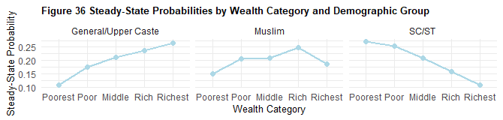

**Solving the equations for we get :**

- the long-term probabilities for each demographic group.

Note : In the above calculation, we took the subset of male-population only so that the large unemployed female does not incorrectly influence the estimates.

**Lerman-Yitzhaki Mobility Index :** Finally, the Lerman and Yitzhaki Mobility Index is another metric designed to measure the extent of mobility within a system, focusing on the changes in individuals' ranks within a distribution over time. Unlike other indices ( e.g., Shorrocks or Bartholomew) it can be decomposed to show both upward and downward mobility. This makes it particularly useful for understanding the directional aspects of mobility along with the magnitude . The Lerman and Yitzhaki Mobility Index is based on the concept of rank changes. It quantifies (Downward Mobility) the extent to which individuals move to lower ranks and (Upward Mobility) the extent to which individuals move to higher ranks.

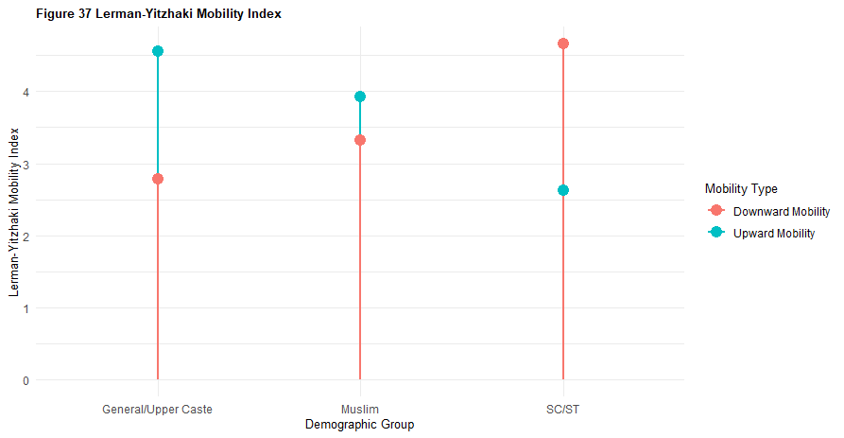

**Solving from our we get :**

, ; , ;

The analysis of the Lerman-Yitzhaki Mobility Index and the steady-state probabilities by wealth category and demographic group presents a revealing picture of socio-economic mobility within India. The upward and downward mobility trends distinctly vary among the General/Upper Caste, Muslim, and SC/ST groups.

For the General/Upper Caste population, upward mobility () significantly surpasses downward mobility (), suggesting a relatively fluid socio-economic landscape where individuals have a higher propensity to improve their socio-economic status. The steady-state probabilities further indicate a progressive increase from the poorest to the richest category, illustrating an overall upward trajectory in wealth accumulation. Conversely, the Muslim population exhibits a restricted mobility pattern with upward mobility () being almost same (or, slightly higher) as downward mobility (). The steady-state probabilities show a peak at the middle wealth category, highlighting a plateau effect where significant upward movement beyond the middle class becomes challenging. The SC/ST population, however, faces the most significant barriers to upward mobility. With a downward mobility index () that far exceeds upward mobility (), there is a pronounced risk of socio-economic regression. The steady-state probabilities for this group demonstrate a declining trend from the poorest to the richest categories, underscoring the entrenched obstacles that hinder their progress.

These findings paint a stark picture of socio-economic stratification in India, where systemic inequities manifest in differing mobility patterns across demographic groups. The data underscores the critical need for targeted interventions to address these disparities, ensuring equitable opportunities for upward mobility across all segments of the population.